
INTELLIGENT FRAUD DETECTION & RISK SCORING SYSTEM
Use Case Diagram

Business Analyst Project Report
Prepared By: Soundarya S
Role: Business Analyst
Date: October 2025
Version: 1.0

USE CASE DIAGRAM – DESCRIPTION
Intelligent Fraud Detection & Risk Scoring System
This document contains:
- Text Description of the Use Case Diagram
- Placeholder to attach the visual Use Case Diagram (draw.io)

1. Visual Use Case Diagram
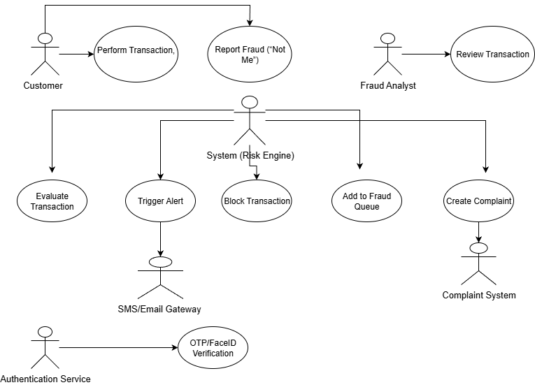

2. Text Description of Use Case Diagram
Actors
- Customer – Initiates transactions, receives alerts, reports fraud
- Fraud Analyst – Reviews flagged transactions
- System (Risk Engine) – Evaluates transactions, assigns risk score
- SMS/Email Gateway – Sends notifications
- Authentication Service (OTP/FaceID) – Validates user identity
- Complaint System – Stores fraud complaint tickets

Use Cases
1. Perform Transaction (Customer)
- Customer initiates a transaction
- System receives and evaluates it
2. Evaluate Transaction (System)
- System collects data (amount, device, IP, GPS)
- Applies fraud rules
- Calculates risk score
3. Trigger Alert (System → SMS/Email Gateway)
- System sends a warning or block alert to the customer
4. OTP/FaceID Verification (Authentication Service)
- System requests OTP
- Customer enters OTP
- Service validates the OTP
5. Block Transaction (System)
- If risk score is 90 or above, the system blocks the transaction immediately
6. Report Fraud ("Not Me") – Customer
- Customer reports suspicious activity
- System blocks card
- System generates fraud complaint
7. Add to Fraud Queue (System → Fraud Analyst)
- High-risk or blocked transactions appear in the Fraud Queue
8. Review Transaction (Fraud Analyst)
- Analyst reviews details
- Approves or rejects the transaction
9. Create Complaint (System → Complaint System)
- Auto-generated complaint with a unique complaint ID

3. Use Case Relationships
Relationship | Explanation
Customer → Perform Transaction | Primary interaction
System → Evaluate Transaction | Core fraud logic
System → Authentication Service | Handles OTP/FaceID verification
System → SMS/Email Gateway | Sends alerts and notifications
System → Fraud Queue | Routes high-risk transactions
Fraud Analyst → Review Transaction | Manual investigation workflow
System → Complaint System | Auto complaint creation

